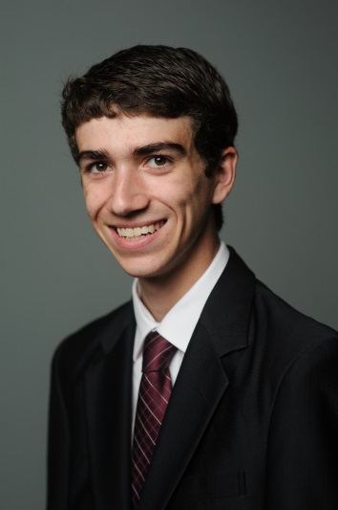

Jacob Tucker

914 Crown Pointe Estates Dr, Wildwood MO 63021

tuckerjacob20@gmail.com

(314) 570 2528

|  |  |  |
| --- | --- | --- |
| Education | | |
| 2015 – Present |  | Bachelor of Science in Computer Science 2018  Master’s in business Administration 2017  *The University of Alabama –Tuscaloosa, AL*  Engaged in the Honors College  STEM Path to the MBA |
| 2011 – 2015 |  | High School Diploma  *Eureka High School – Eureka, MO*  Graduated first in a class of approximately 500 students  National Honor Society |
| Leadership Activities and Awards | | |
| 2015 |  | Instructed first year interns in company tools and practices at Oasis Digital Solutions Inc. |
| 2013 – 2015 |  | Guided youth group as part of the Youth Leadership Team |
| 2012 |  | Selected to attend Missouri Scholars Academy, an elite summer program for the top 330 students in the State of Missouri |
| 2011 – 2015 |  | Invested in peers as a Students With a Testimony Leader |
| 2011 – 2014 |  | Led FTC Robotics Team 3658 to three State Competitions and one World Competition |
| Work Experience | | |
| Summer 2015 |  | Web Developer  *Oasis International Ministries –St. Louis, MO*  Developed a web application to manage donations and deliveries for refugees in the St. Louis Area.  Communicated with Leadership to establish clear, attainable goals.  Updated and deployed the application regularly according to continuous feedback. |
| 2014 – 2015 |  | Web Development Intern  *Oasis Digital Solutions Inc. – Des Peres, MO*  Developed three production single-page web applications, two of which for real clients.  Individually designed and created a production single-page web application for a client.  Experienced in AngularJS development.  Trained and led first-year interns with fellow second-year intern Maneesh Tewani  Utilized industry tooling including Git and JIRA daily. |